Emergency
Mobile Alert

Produced 2022 by Accessible Formats Service, Blind Low Vision NZ,
Auckland
Total print pages: 1
Total large print pages: 4

Notes for the Large Print Reader
Main text is in Arial typeface, 18 point.
Headings are indicated as:

Heading 1

Heading 2
Heading 3

Emergency Mobile Alert
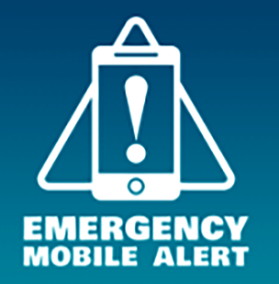
Visit getready.govt.nz to check if your phone is compatible.

If your life, health or property is in serious danger, an Emergency Mobile Alert could be sent to your mobile phone.
Emergency Mobile Alert is a message sent to your mobile phone by an authorised agency. It will make a loud noise to alert you.

What should I do if I receive an Emergency Mobile Alert?
Stop what you're doing and follow the instructions.
Emergency Mobile Alert messages are only sent:
- if there is a serious threat to life, health or property; or
- once or twice a year for testing purposes.
If you receive an alert, take it seriously and do what it says.
Not all phones are capable of receiving Emergency Mobile Alert, so if you receive an alert, let others know.\

Do I need to sign up to receive Emergency Mobile Alerts?
There is no need to sign up or download an app. Alerts are targeted to affected areas, so you will only get them if the emergency is in your area.
If your phone is on, capable of receiving them and inside the targeted area, you should get the alerts. You can find out whether your phone is capable of receiving alerts at getready.govt.nz.

Who can send Emergency Mobile Alerts?
Emergency Mobile Alert messages can only be sent by:
• National Emergency Management Agency
• Civil Defence Emergency Management Groups
• NZ Police
• Fire and Emergency New Zealand
• Ministry of Health, and
• Ministry for Primary Industries.

Emergency Mobile Alert does not replace other channels
Emergency Mobile Alert is only an additional channel to keep you safe and informed in an emergency. The alerts do not replace other alerting systems, or the need to take action after natural warnings.

Ways to Stay Informed
You should still be prepared for an emergency, and you shouldn't wait to get an alert before you act. If you feel your life is in danger, don't wait for an official warning. Take immediate action.
Take the time to make your own emergency plan which includes what to do, where to go, who can help you and who might need your help. You can make a plan online at getready.govt.nz.

How does Emergency Mobile Alert work?
1. Authorised agency determines affected area and creates alert.
2. Alert is broadcast from relevant cell towers.
3. Capable mobile phones in the affected area receive the alert.
Emergency Mobile Alert uses a dedicated signal, so it is more reliable in an emergency when mobile phone and internet traffic could overload the network.
It doesn't matter which network you are on. Any capable phone entering the area during the broadcast period will receive the alert.

Can I opt out of receiving Emergency Mobile Alerts?
As Emergency Mobile Alert is about keeping you safe, you won't be able to opt out of receiving Emergency Mobile Alerts. Alerts do not target specific phones, instead they are broadcast to a targeted area that is at risk. Emergency Mobile Alert does not use your mobile phone number or collect information about you.
For more information on Emergency Mobile Alert, visit getready.govt.nz

