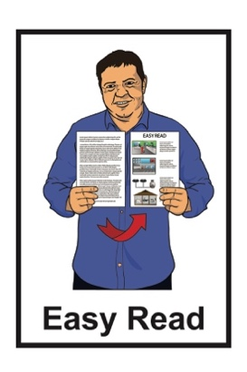
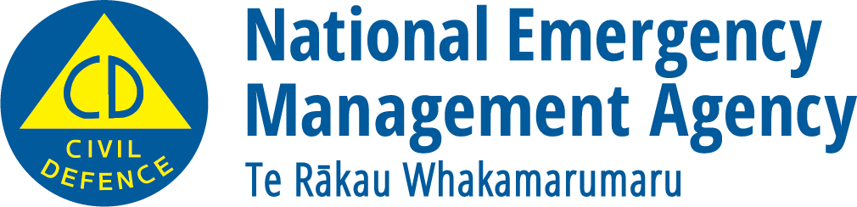

What you can do to be
ready for a flood

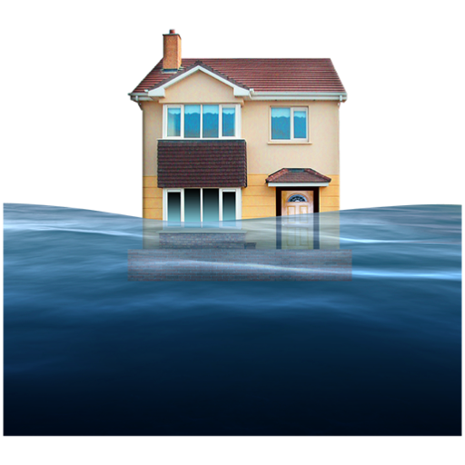

Updated: June 2026

Before you start

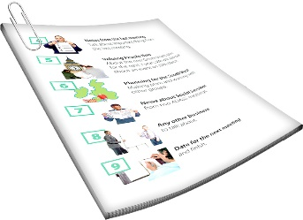
This is a long document.

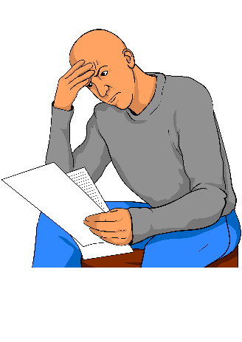
It can be hard for some people to read a document this long.

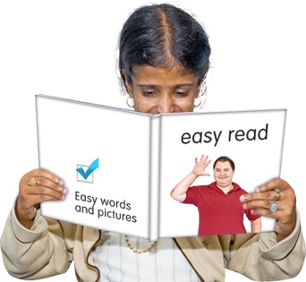
Some things you can do to make it easier are:
read it a few pages at a time
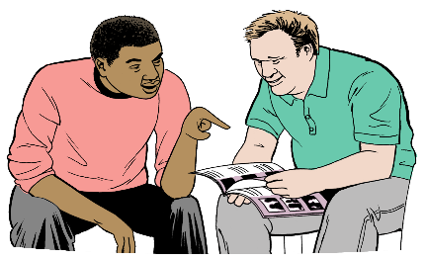
set aside some quiet time to look at it
have someone read it with you to support you to understand it.

What you will find in here

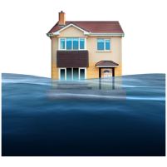
Page number:

What is a flood? 4
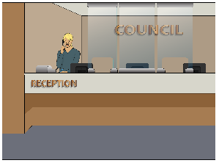

Things your local council can do to support you getting ready for a flood 7

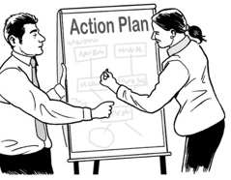
Things you can do to be ready
for a flood 10
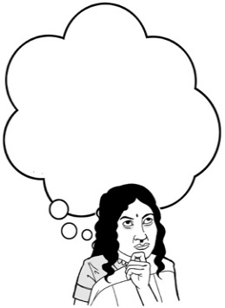
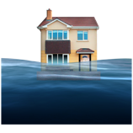

What to do if you think a flood is
going to happen 14


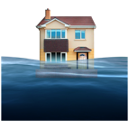
What to do during a flood 16

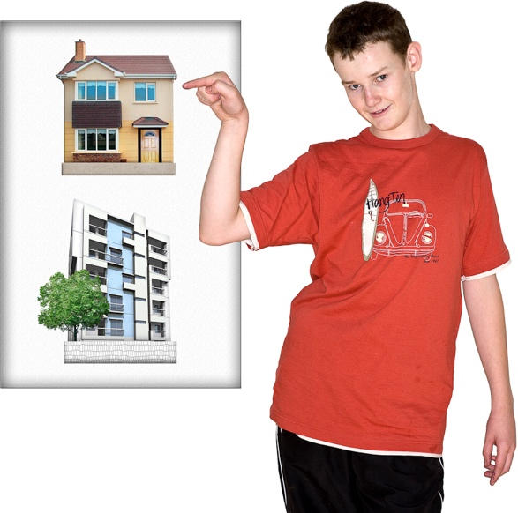

What to do after a flood 22
Page number:

What to do if your property is
damaged after a flood 26

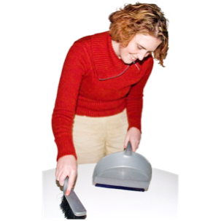
Cleaning up after a flood 28

What is a flood?

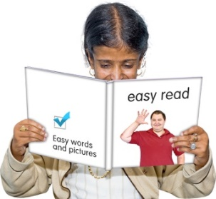
The information in Easy Read document is about what to do if a flood happens.

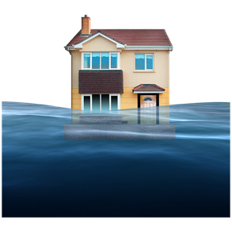
A flood is when a large amount of water rises to a dangerous level.

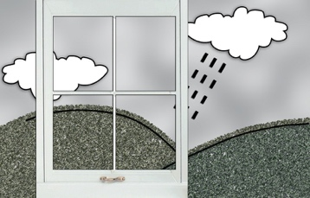

Floods can be caused by things like:
a big storm also known as a hurricane
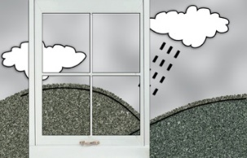
the breaking of a dam or another place where water is collected
heavy rain / lots of rain.

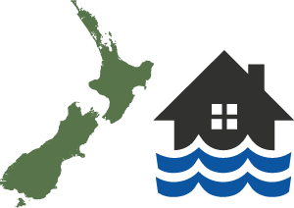
Floods happen often in Aotearoa New Zealand.

How long a flood takes to happen can be either:
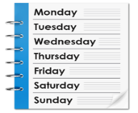
a short time such as a few minutes / hours
a longer time such as a few hours / days.

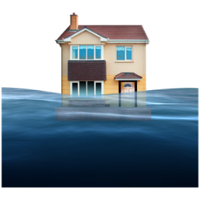
A flood can:
cause a lot of damage
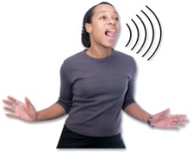
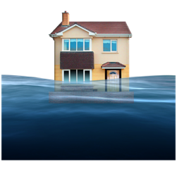
put people in a lot of danger.

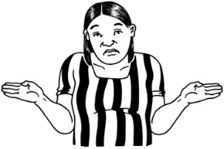
It is not always possible to know when flooding might happen.

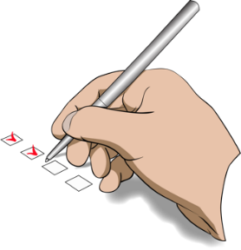
There are things we can do to:
be ready if a flood happens
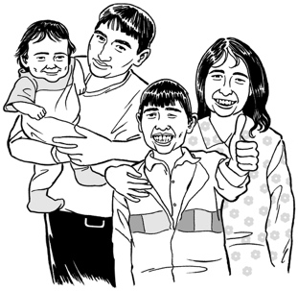
protect ourselves
protect our whānau / family.

Things your local council
can do to support you
getting ready for a flood

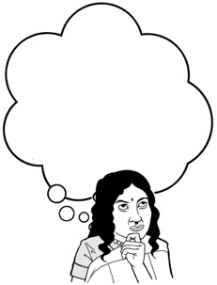
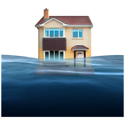
It is a good idea to find out what the flood risk is like where you live.

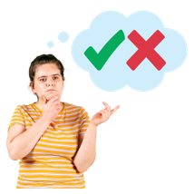
The flood risk will tell you how
likely it is a flood will happen.

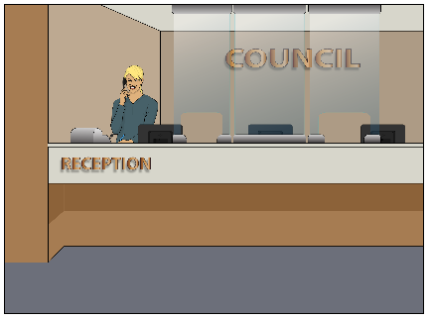
You can find out what the flood risk is for where you live by asking your local council for information.

Houses that tend to be more at risk from floods are usually built:
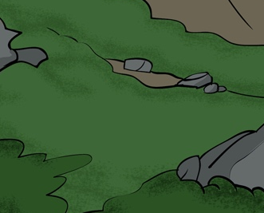

in low-lying areas
near open and flowing water such as:
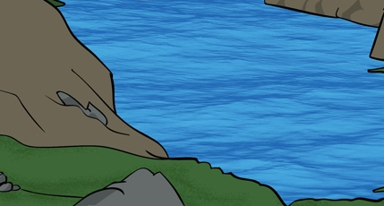
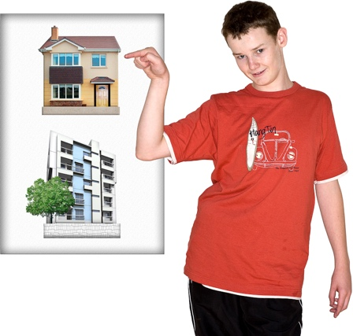
- rivers / streams
- lakes
- the sea.

If your house is in an area at risk from floods your local council should tell you about how to evacuate if you need to.

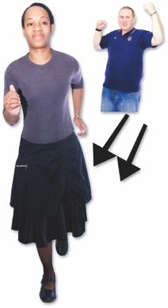
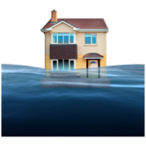

Evacuate means to get to a safe place away from danger.

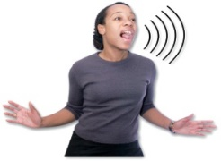
Your local council should tell you about:
how they will let people know about a dangerous flood

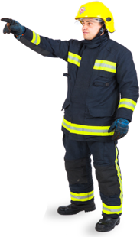
how they will evacuate people if a flood happens
Safe place
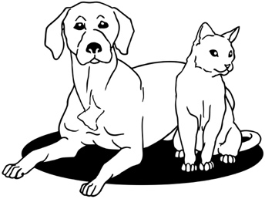
what you should do with any animals you own if a flood happens.

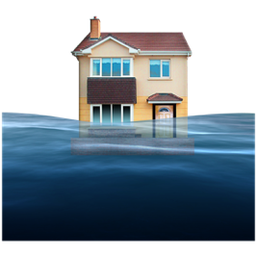

Your local council should also be able to give you advice.

This advice on how to make your home at less risk of flooding during very bad weather.

Things you can do to get ready for a flood

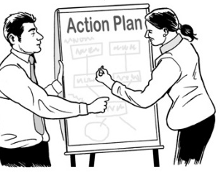
The best way to get ready for a flood is to make a plan.


Having a plan will make it easier for you to know what to do if a flood happens.

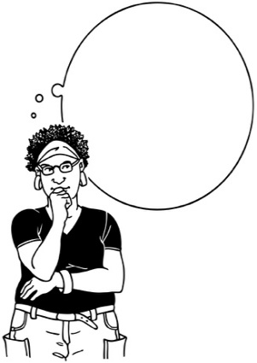
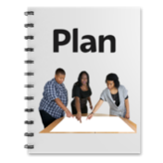

It is important to practise what you will do in a flood so you can act quickly to keep yourself safe if it happens.

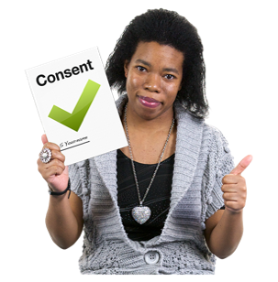
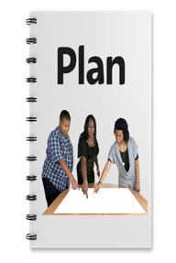
Practise is when you do something lots of times so that you can get
good at doing it.

It is a good idea to think about what supplies you might need.
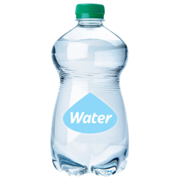

Supplies can be things like:
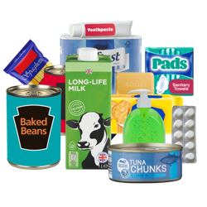
a stock of bottled water for everyone in your house
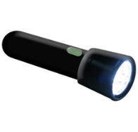

a cupboard stocked with food
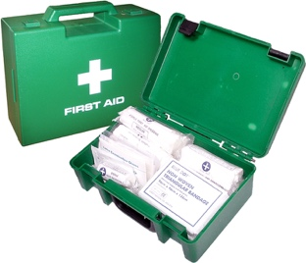
a torch with extra batteries
a first aid kit.

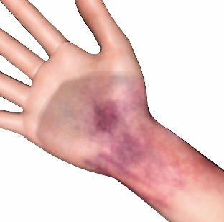
First aid is when you give medical help to someone who is injured to:
save the life of that person
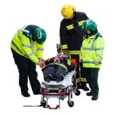
stop their injury from getting worse.

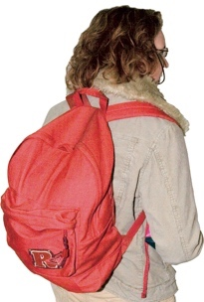
It is also a good idea to put together a grab bag that you can take with you in an emergency.

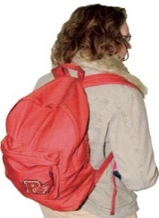
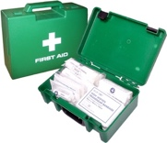
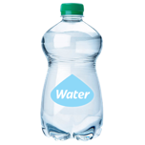
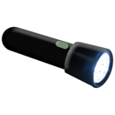

A grab bag is a small backpack of essential items that you can take
with you if you need to get away
from danger very quickly.

If you have house insurance you should make sure it is up to date.


Insurance is when you pay money
to an insurance company so that
they will assist you if something
goes wrong.

You can have insurance for:
your house

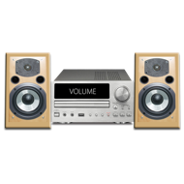
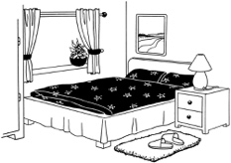
your house contents – the things inside your house.

You should make sure your insurance says you can claim for any damage a flood does to your home.

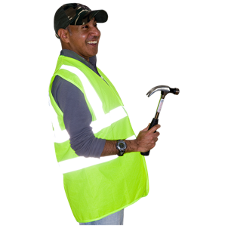
Having insurance will help you get things fixed quicker if your house is damaged by a flood.

What to do if you think a flood
is going to happen

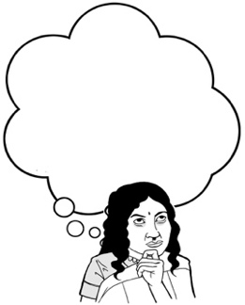
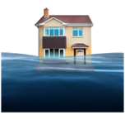
If you think a flood is going to happen there are some things you should do.

It is important to keep up with any information.

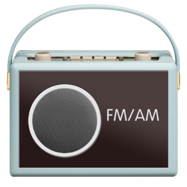
Places you might find information include:
your local radio station
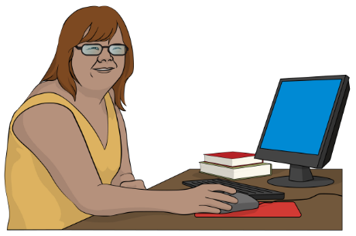
groups on the internet such as your local Civil Defence Emergency Management Group.

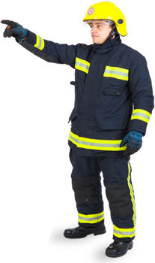
You should make sure you follow any instructions given to you by emergency services.

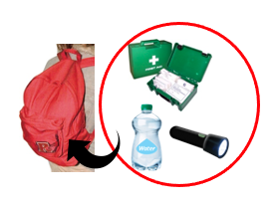
You should have your grab bag ready in case you need to evacuate.


Safe place
You should follow any orders that tell you to evacuate to stay safe.

You should evacuate straight away if you do not feel safe even if you have not been told to.

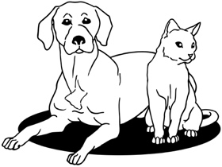
You should move any animals to a safe place so they will be away from any flood water.
Safe place
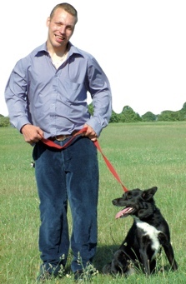

If you have to leave your home you should take your pets with you.

You should move some things in your house to the highest you can to keep them out of the water.


The sorts of things you should move include:
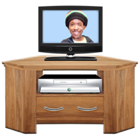
things that are worth a lot of money such as jewellery
electrical items such as TV sets
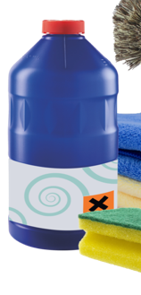
any chemicals you might have such as things you might use to clean.

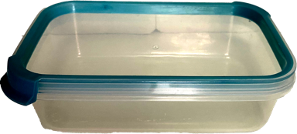
You should put any important items in containers that can be tightly closed to stop water getting in.

You should lift any items made of fabric / cloth off the floor such as:
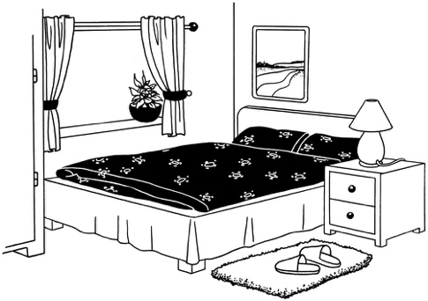
curtains
bed covers
rugs.
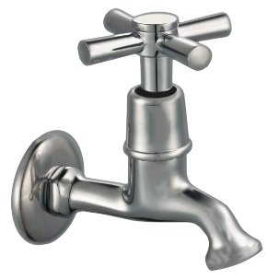

You may also be told to turn off utilities when a flood happens.

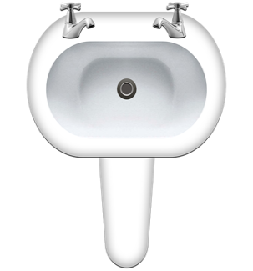

Utilities are things like:
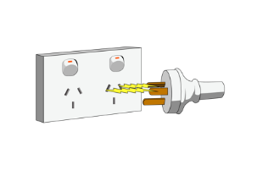
the water that comes out
of your taps
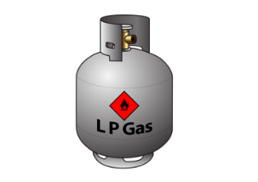
your electricity supply
your gas supply.

What to do during a flood


Floods can happen very quickly without warning.

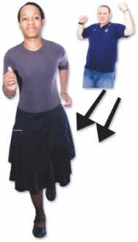
It is important to act straight away if you see any rising water / water getting higher.

If you see any rising water you should not wait for official warnings.

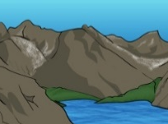
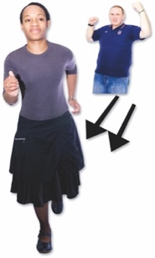
You should:
get to high ground straight away
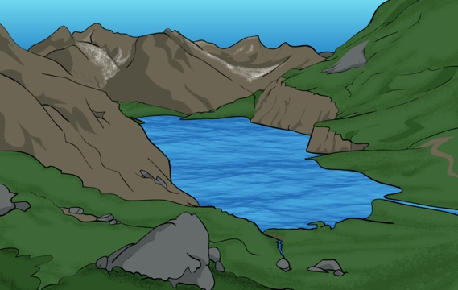

stay away from any water.

Water from a flood can be very dangerous.

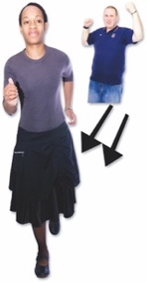
You must never try to move through water caused by a flood.

This means you must not:

try to walk through flood water

try to swim in flood water
try to drive through flood water.

Flood water is often contaminated water.

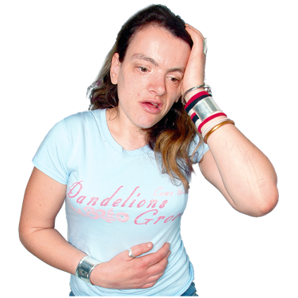
Contaminated means:
something has made it dirty
it can make you very sick.
Flood water is often contaminated by things like:
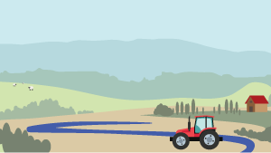
water that has run off from farm land
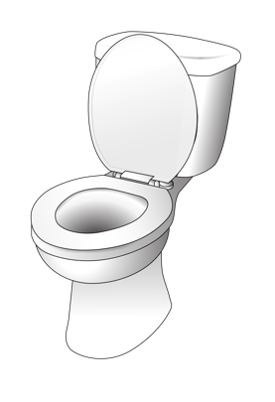
chemicals that have been used on farm land
sewage which is waste
water / poo that has come from toilets.

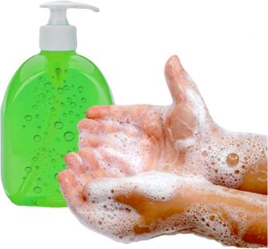
You should always make sure you wash yourself very well after you have touched flood water.

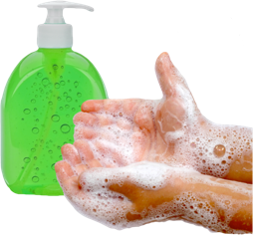
If you do touch any flood water you should make sure you:
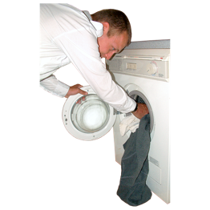
wash your hands
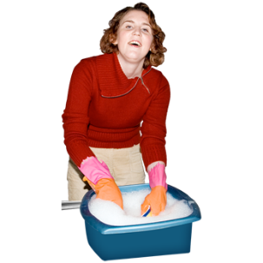
wash your clothes
wash any other things the flood water has touched.

What to do after a flood

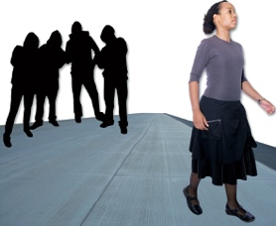
You should not go back to your home after a flood until you have been told it is safe.

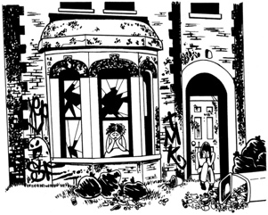
It might not be safe to go back to your home even when any flood water has gone.

You should stay away from any areas that have been damaged by the flood.

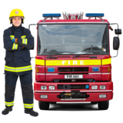
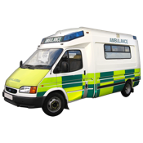
This is to make sure you:
keep yourself safe
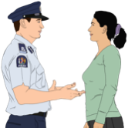
do not get in the way of the emergency services.
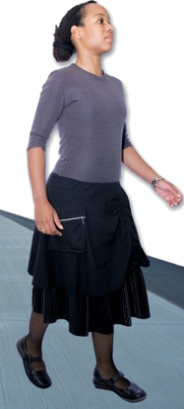
You should move around very carefully after a flood as the ground may be very slippery.

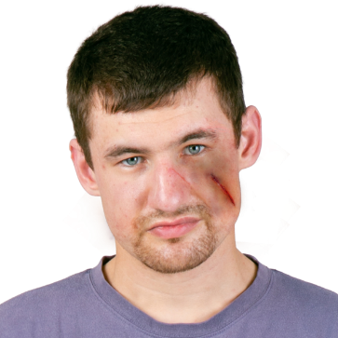
There may also be things on the ground that have been damaged by the flood that could hurt you.

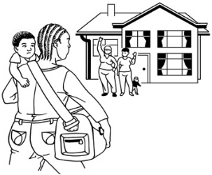
If it is safe to do so you should check on people nearby who might need your help such as:
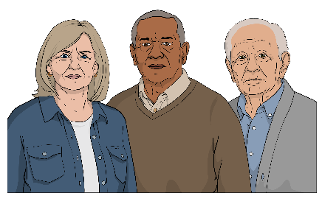
your neighbours
older / disabled whānau

anyone else who might need your support.

You should throw away any food items that have been touched by flood water including:
drinking water
canned food.
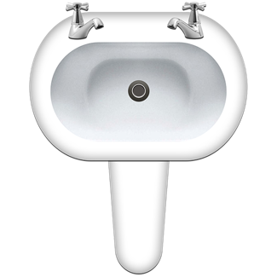
You should not use any water from your taps until you are sure it is not contaminated.

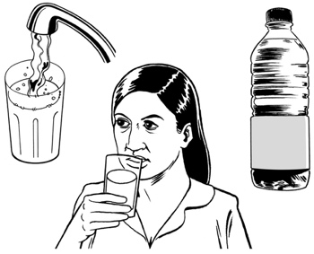
This means you should not:
drink any tap water
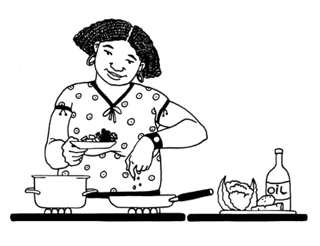
wash food with tap water
cook food with tap water.

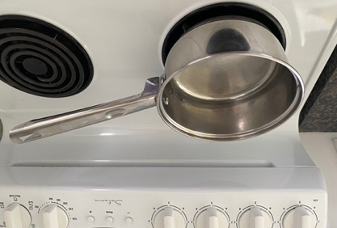
Your local council may tell you to boil any water you use until they tell you otherwise.

You can find out more information about food safety in an emergency at the Ministry for Primary Industries website here:

www.mpi.govt.nz
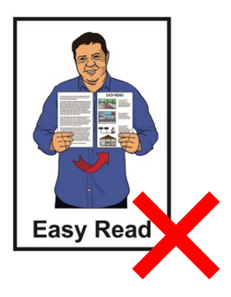

This information is not in Easy Read.

To find out what support you can get if you have been affected by an emergency go to this website:

shorturl.at/Jwy3q

What to do if your property is
damaged after a flood

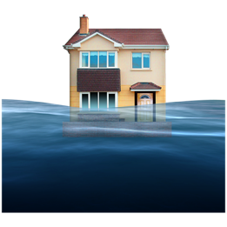
It is possible that a flood could damage your property.

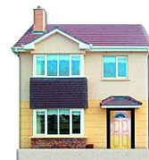
Your property could be things like:
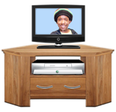
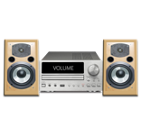
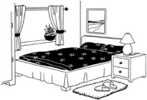
the outside of your house
things inside your house

your car
things in your garden such as sheds.

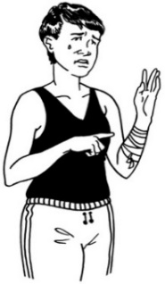
If your property is damaged you should not do anything that could:
be dangerous to you
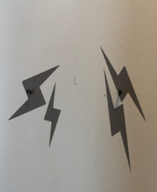
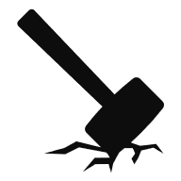
cause more damage.

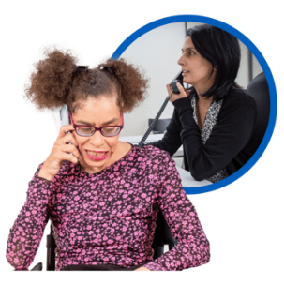
If you have insurance you should tell the insurance company about the damage the flood has done as soon as possible.


You should take photos of any damage caused by a flood.


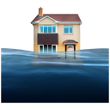
Having photos will mean the insurance company can look at your claim much faster.

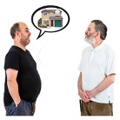
If you rent your home you should tell your landlord about any damage.

Cleaning up after a flood

After a flood it is very important to:
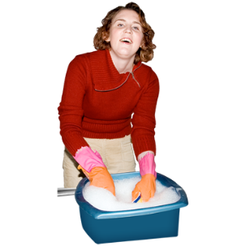
clean your house really well
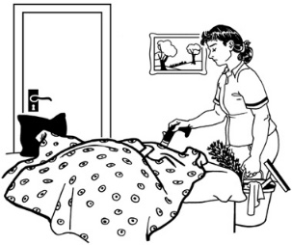
clean everything inside your house really well
make sure everything is dried out properly.

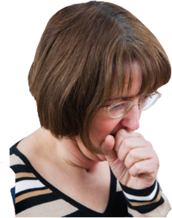
This is because water from a flood can make the air in your home unhealthy to live in.

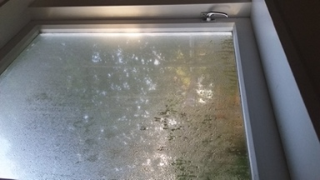
When things get wet for more than 2 days they usually get mouldy.

There may also be germs / bugs in your home after a flood.

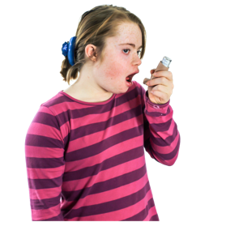
Mould can make some people very sick such as people who have:
asthma
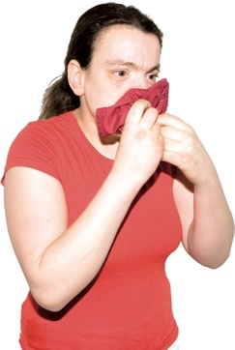
allergies
other breathing problems.

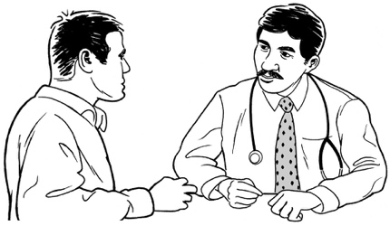
If you are worried you should talk to your doctor if you have any questions about:
cleaning a home that has been flooded
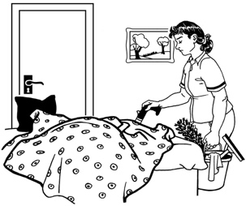
working in a place that has been flooded.

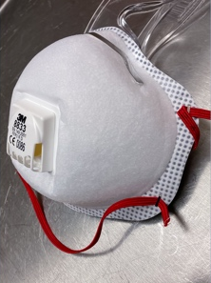
Before you begin cleaning up any mould you should make sure you protect yourself by wearing:
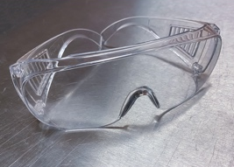
a special face mask called a respirator mask
goggles to cover your eyes
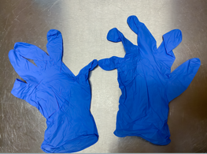
gloves to cover your hands
clothing that covers your:
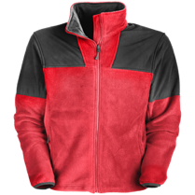

- arms
- legs
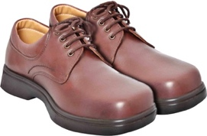
sturdy footwear to protect your feet.

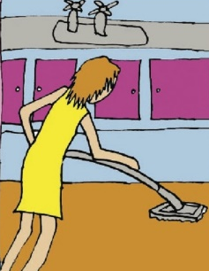
If there is a lot of mould in your house you may want to pay a cleaning company to help you clean it up.

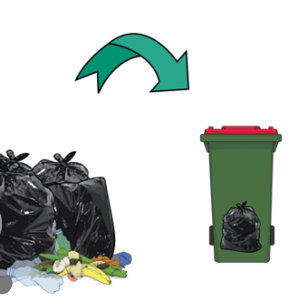
After a flood you should throw away anything that got wet that cannot be cleaned safely.

This includes things like:
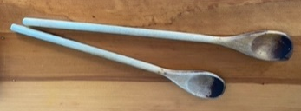
wooden spoons
things you use to cook with that are made of plastic
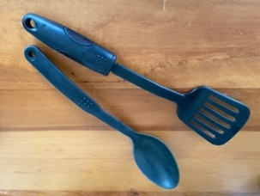
the teats on baby bottles
dummies that a baby might suck.

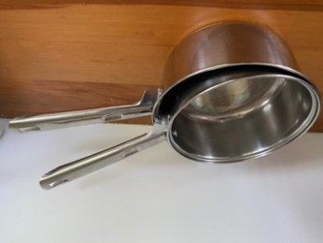
You can clean some things in clean boiling water such as:
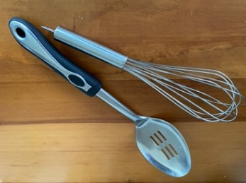
metal pans
things you use to cook with that are made of metal.

Flood water can have lots of silt in it.

Silt is:
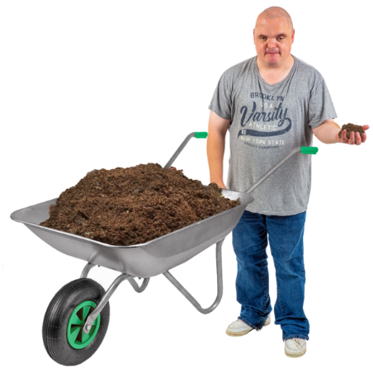
mud
sand
soil.

Silt can have things mixed in that can be:
dangerous
make you sick.

Silt:
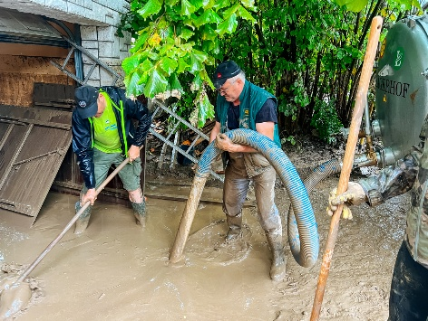
starts out:
- wet
- sticky
becomes:
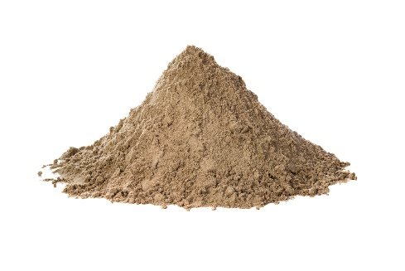
- dry
- dusty
- firm / hardpacked.

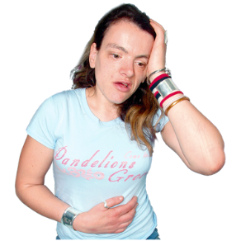
Dust from silt can make some people unwell.

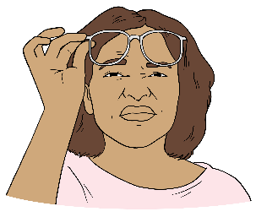
It is important to be safe if you:
see dust in the air
smell / taste dust in the air.
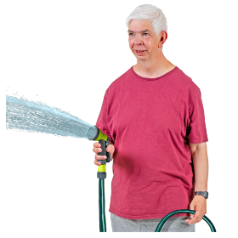
To stop silt from blowing around you should:
keep the surface of the silt wet
cover it to stop it from drying
use something to protect the silt from the wind.

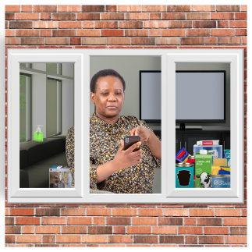
When dust levels are high try to:
stay indoors
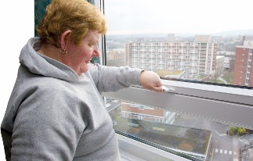
close windows / doors
close other openings like:
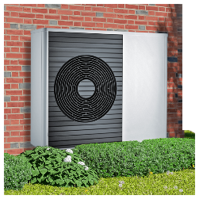
  - car doors
- air vents.

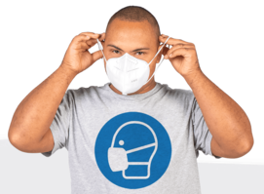
If you cannot get away from dust you should wear a mask like a:
P2 mask
N95 mask.

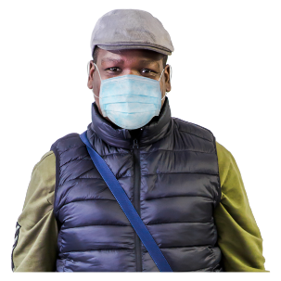
If you do not have these masks you can also wear a surgical mask for some protection.

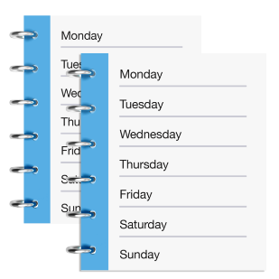
Some of the problems with silt will get less over time.

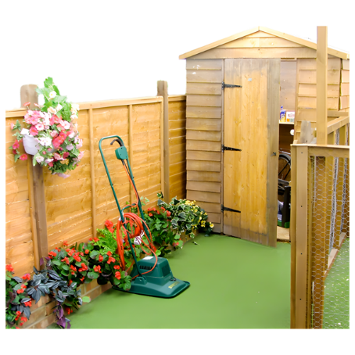
This means you do not need to get rid of all the silt you may find if:
it is in an open area like in a garden
less than 15 millimeters deep.

Follow instructions / advice about removing silt from your local:
council
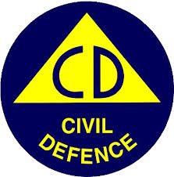
Civil Defence Management Group.

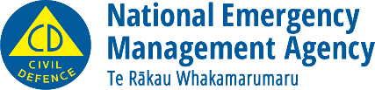
This information has been written by the National Emergency Management Agency.


It has been translated into Easy Read by the Make it Easy Kia Māmā Mai service of People First New Zealand Ngā Tāngata Tuatahi.

The ideas in this document are not the ideas of People First New Zealand Ngā Tāngata Tuatahi.
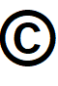
All images used in this Easy Read document are subject to copyright rules and cannot be used without permission.



Make it Easy uses images from:


- Photosymbols

- Change Images


- Huriana Kopeke-Te Aho

- SGC Image Works

- T Wood


- Studio Rebeko

- Inga Kramer.

