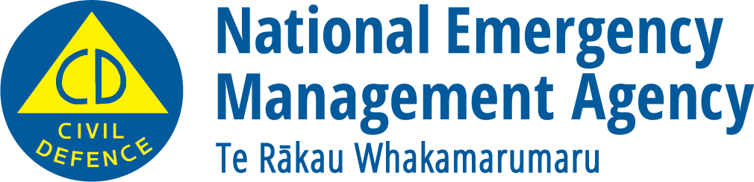
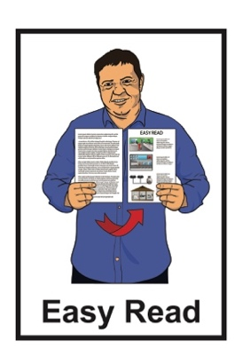

What you can do to

get ready for wildfires
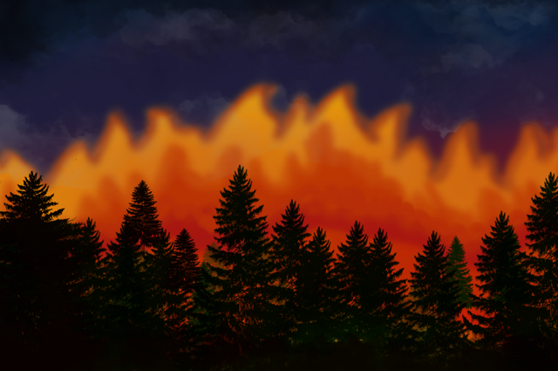

Published: June 2024

What is a wildfire?

The information in this document is about getting ready for wildfires.

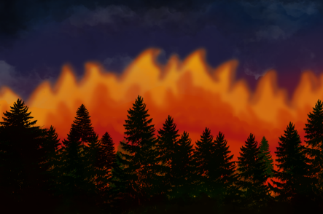
A wildfire is a big fire in a place outside where there are:
grasses
trees
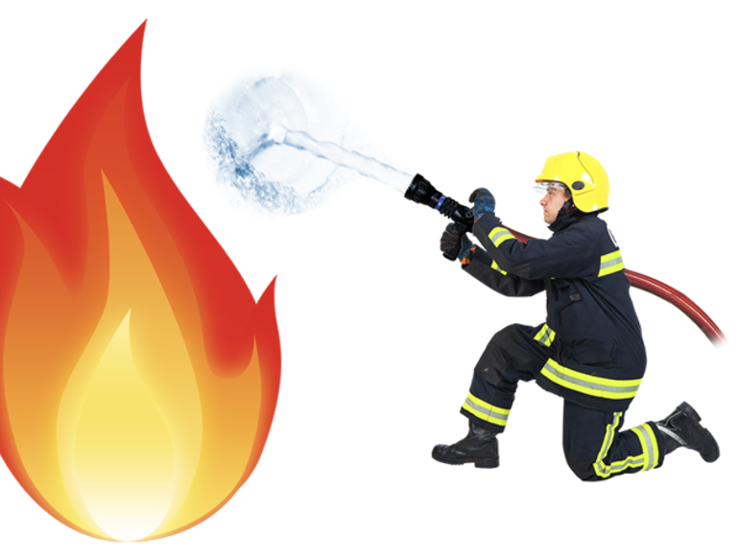
bushes.

Wildfires are dangerous if they get out of control.

This document tells you:
what makes wildfires start
how to keep safe from wildfires
what to do if a wildfire starts near where you live
what to do after a wildfire.

What makes wildfires start?

People start nearly all wildfires in New Zealand.

They start because of things like:
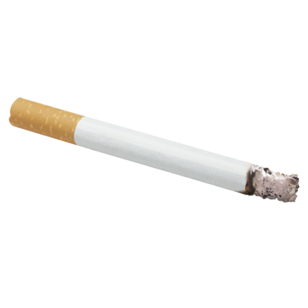
an accident such as someone dropping a cigarette on dry grass
a bonfire getting out of control
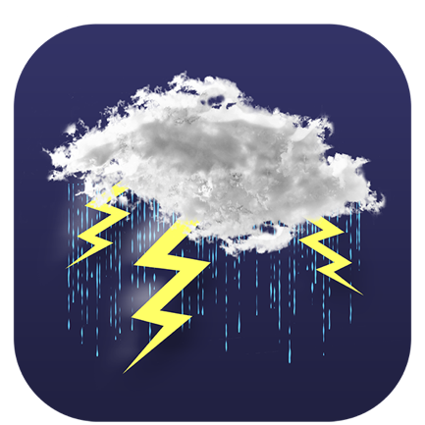
someone setting fire to something on purpose

Some wildfires are caused by lightning hitting the ground.

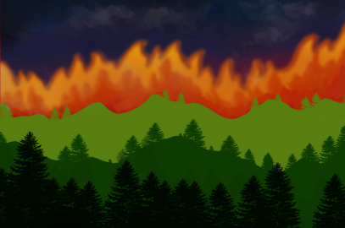
Wildfires can start anywhere where:
there are dry plants nearby
someone makes a spark.
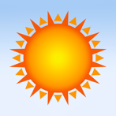

They can happen at any time of year.
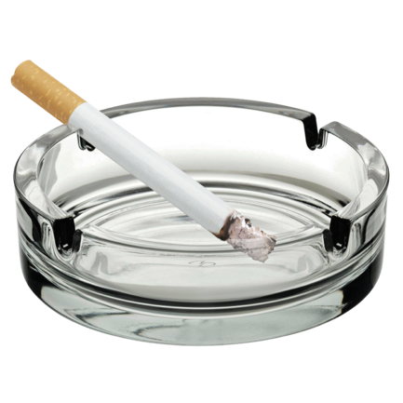

You can stop wildfires from starting by taking extra care when using things that could start a fire outside.

How to keep safe from wildfires

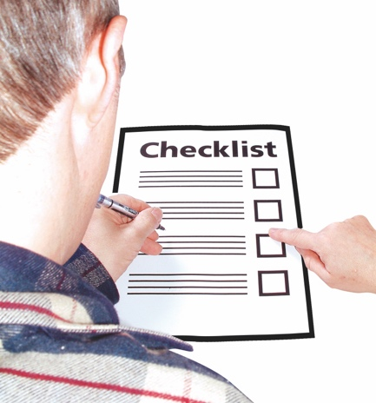
You can get ready for wildfires before they happen.

There are lots of things you can do to keep your property safe from wildfires.

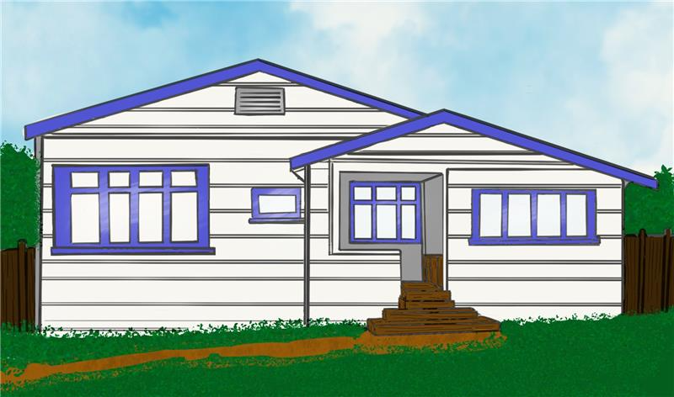
Your property means things like your:
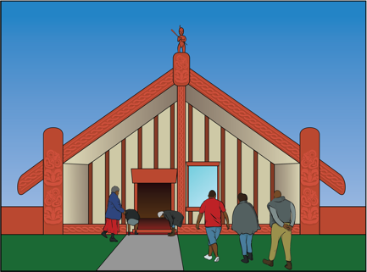
house
marae
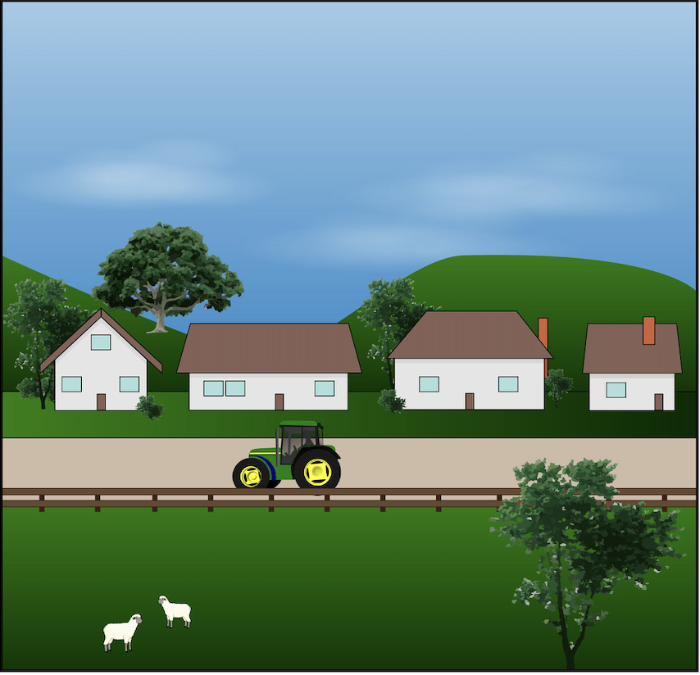
shed
paddocks
garden.

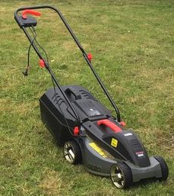
To keep your property safe from the danger of wildfires you should:
cut grass short
water grass to keep it green
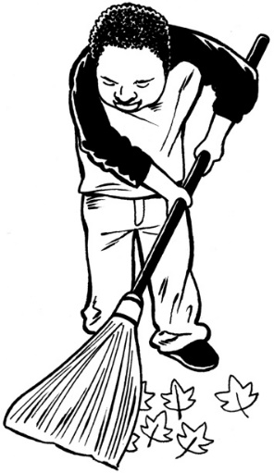
clean dead leaves from gutters
clean dead leaves from decks
clean pine needles from decks
take away plants that burn easily
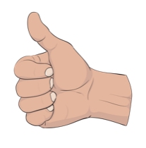
only plant things that do not burn easily.

You should not put things on your garden that burn easily like tree bark.

To keep yourself safe from wildfires you should:
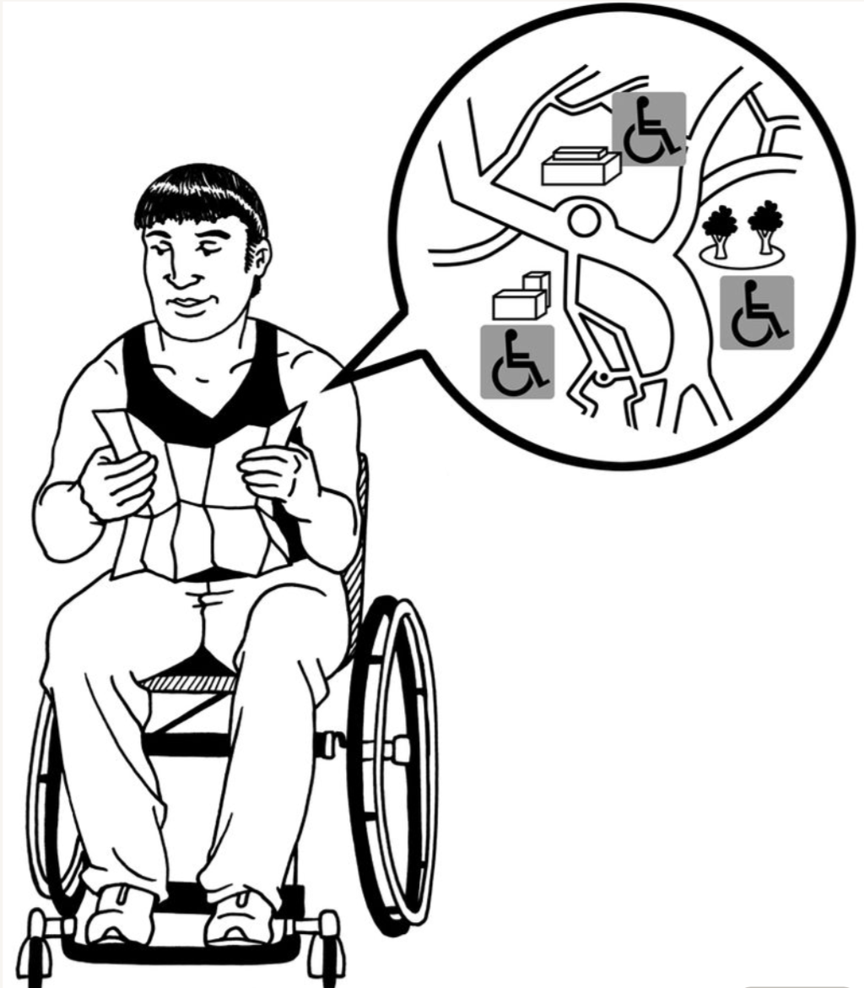
be careful with things that can make sparks like cigarettes
make a plan about how you will leave your property if there is a fire
plan more than 1 way to leave your property.

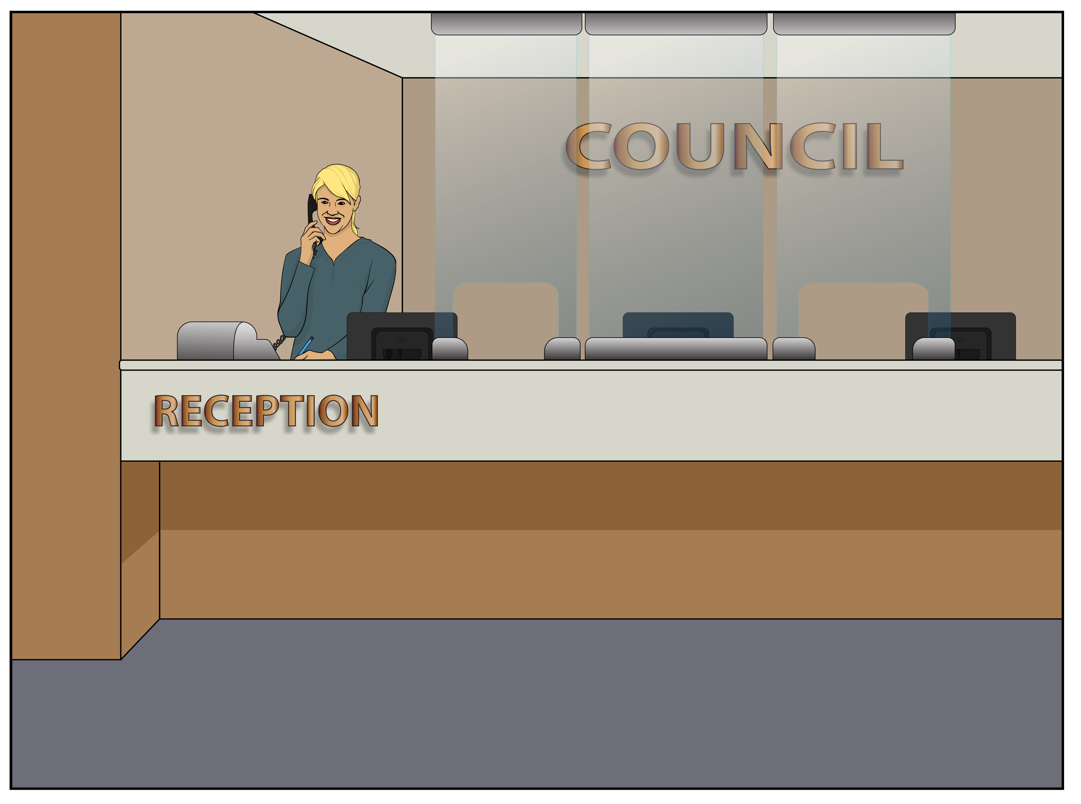
Always check with your local council if it is okay before you have a bonfire.

Your local council website will tell you when it is okay to have a bonfire in your area.

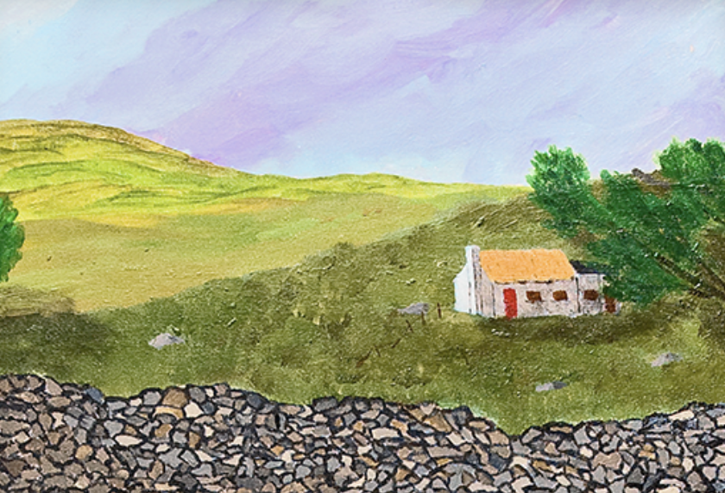
If you live in the countryside make sure your driveway is big enough for fire engines to use.

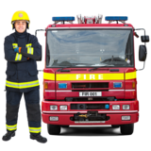
Your driveway should be at least:
4 metres wide
4 metres high.

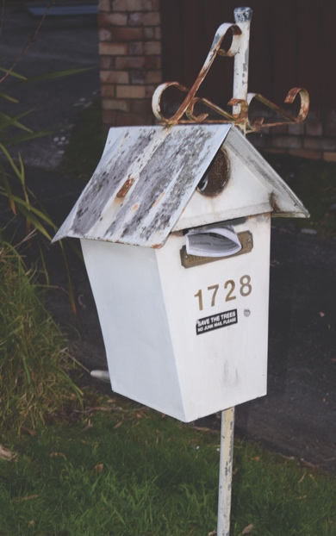
You should also make sure your RAPID number is easy to see.

Your RAPID number is your Rural Address Property Identification number.

It is like your house number.

If there is a wildfire near you

Find a safe place to stay if a wildfire happens near you.

Your safe place may be somewhere:
on your property
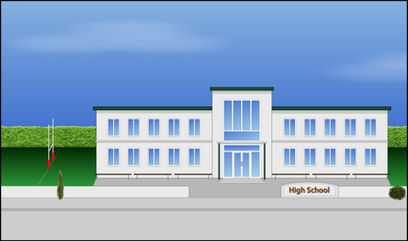
in your community like at a school hall.

Your safe place could be somewhere that has:
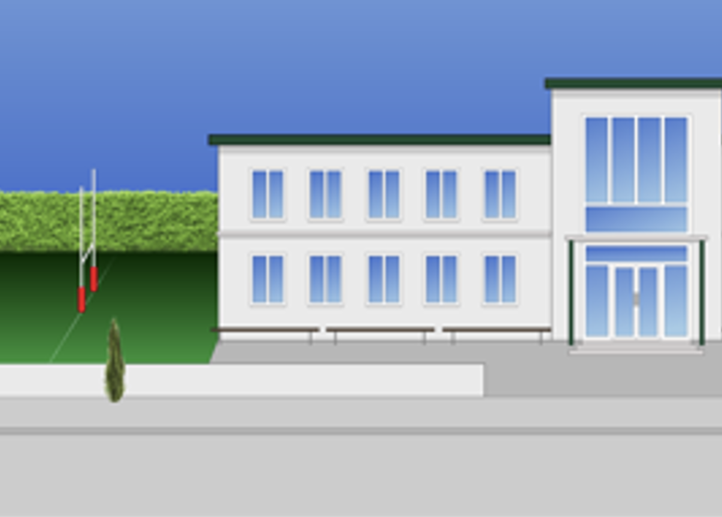
lots of concrete areas that will not burn
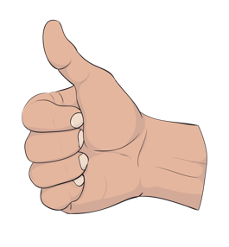
short grass
lots of water.

Make a plan with your family / whānau in case you have to leave your home.
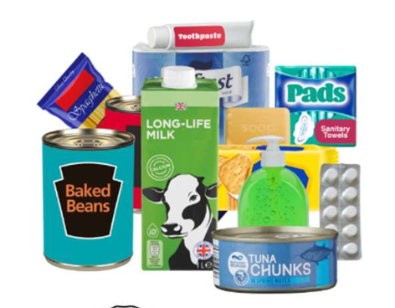

Think about what food you may need as well as other supplies.
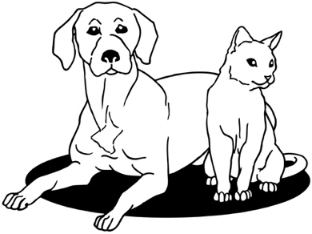

You should include your pets in the plan.

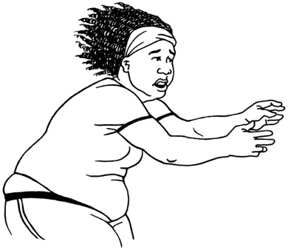
You should leave your home straight away if you feel scared.

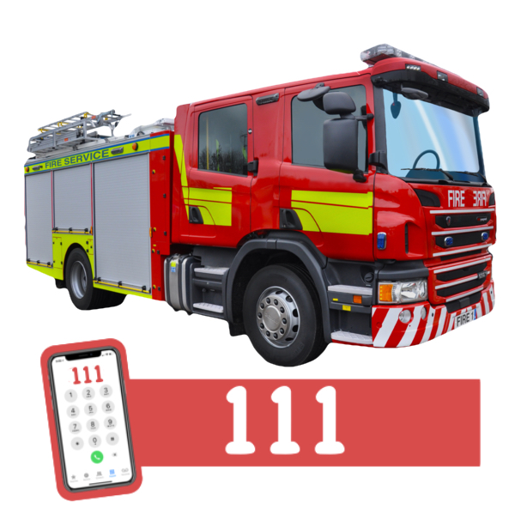
You should call Emergency Services on 111 if:
you cannot get to a safe place
you are in danger
your property is in danger.
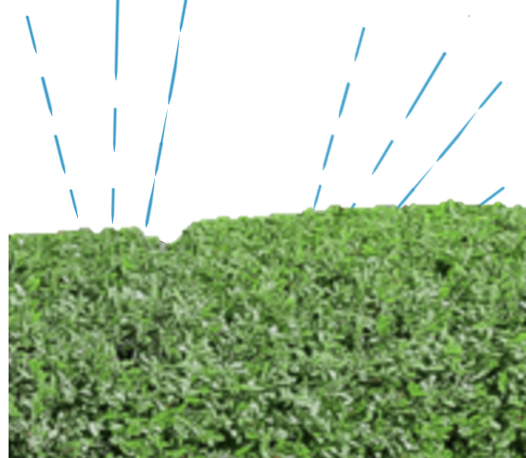
Before you leave your property you should:
turn on any sprinklers
fill gutters with water
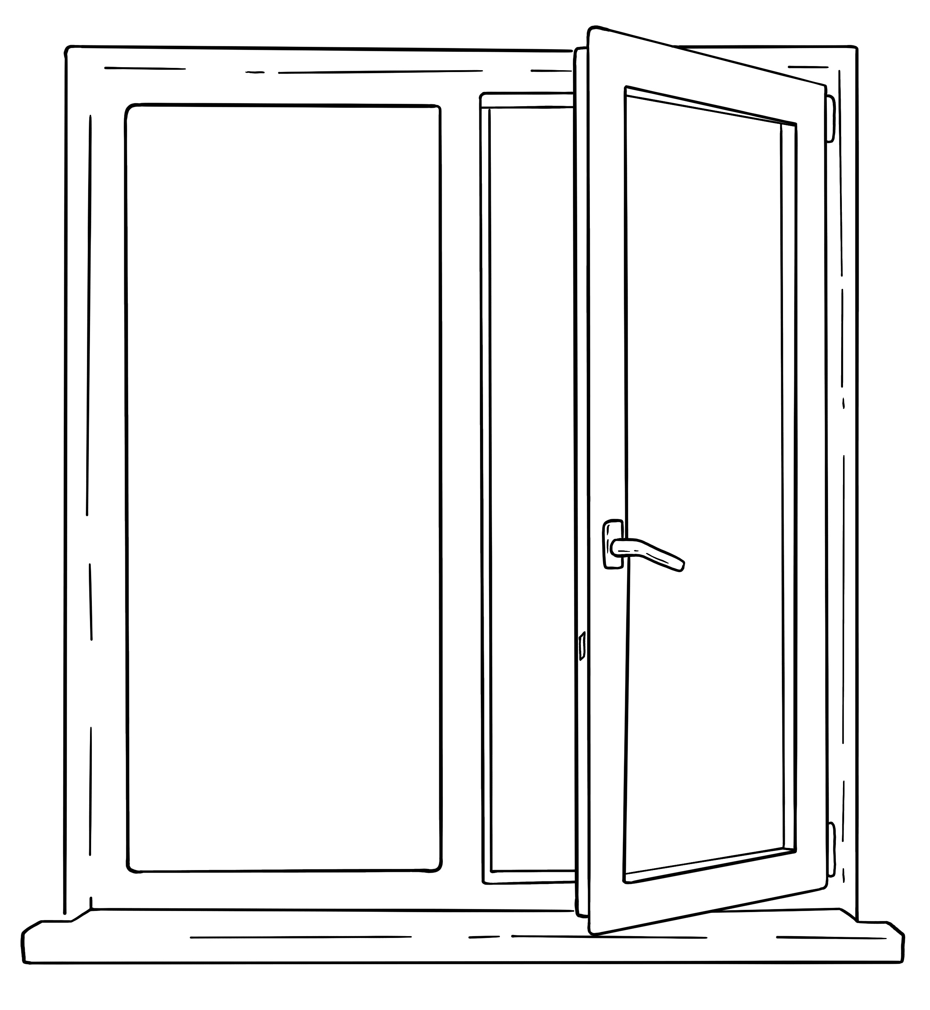
put water on things that can catch fire
close windows / doors
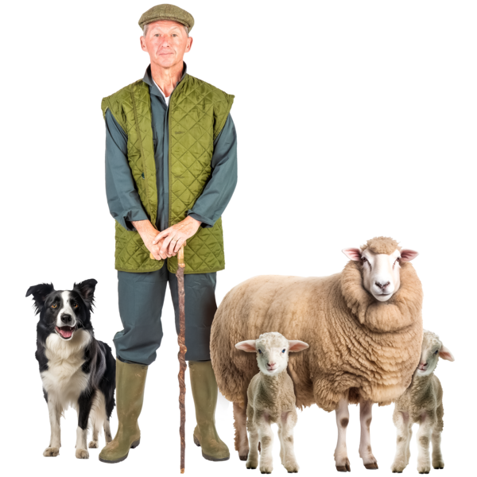
put wet towels on gaps under doors
move animals to a safe place
move cars to a safe place.

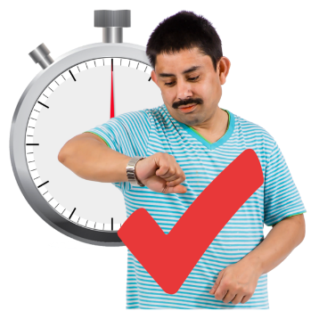
You should only do these things if:
it is safe for you to do so
you have time to do so.

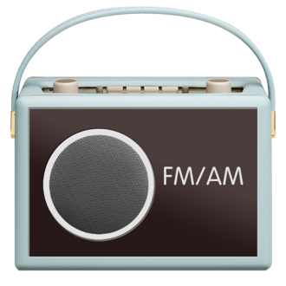
To find out what is going on you can:
listen to the radio
go online.

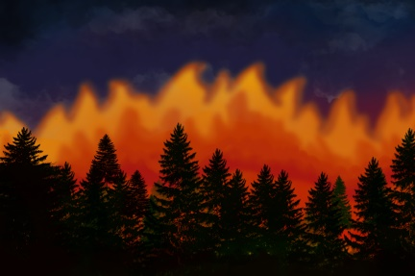
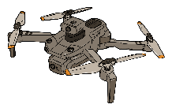
Never use a drone near a wildfire.

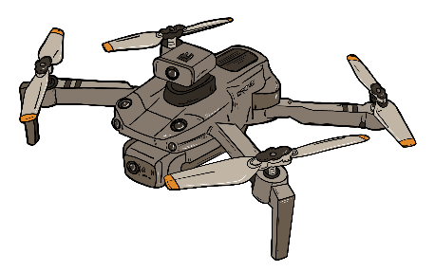
A drone is a flying camera that some people use to take photos from the sky.

Drones stop fire fighters doing their job safely.

What to do after a wildfire

After a wildfire happens you should always follow advice from firefighters.

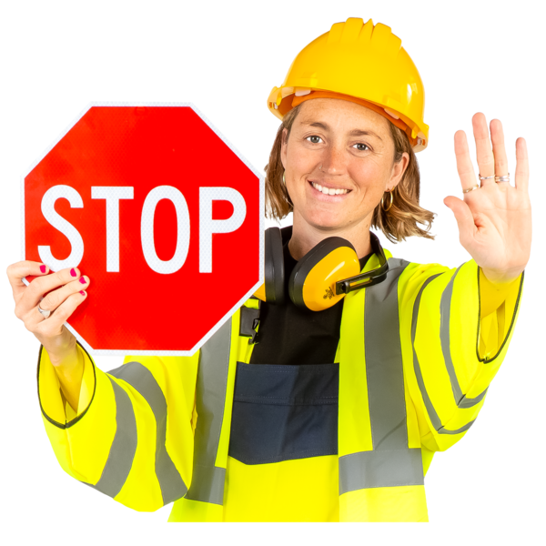
Some roads may be closed after a wildfire.

It is important that you:
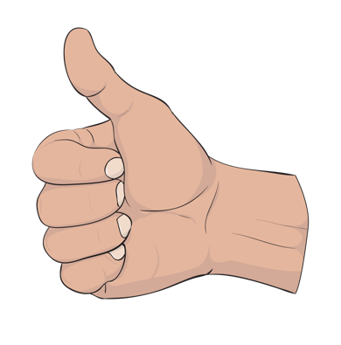
only go back home when it is safe to do so
follow any instructions from firefighters
listen for news on the radio / online in case the fire gets worse again.

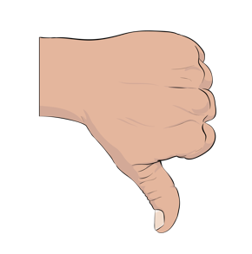
The fire may have damaged some of your things:
on your property
in your home.

There may be a smell of smoke in the air for a while after the fire has gone.

Some of your things may have dirt on them that can make you sick like:
foam from fire fighting equipment
soot from the fire.

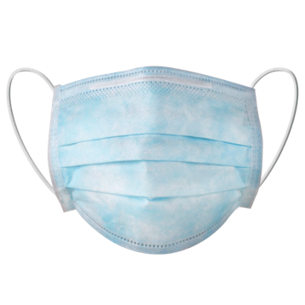
To keep yourself safe when you clean up after a wildfire you should wear clothing like:
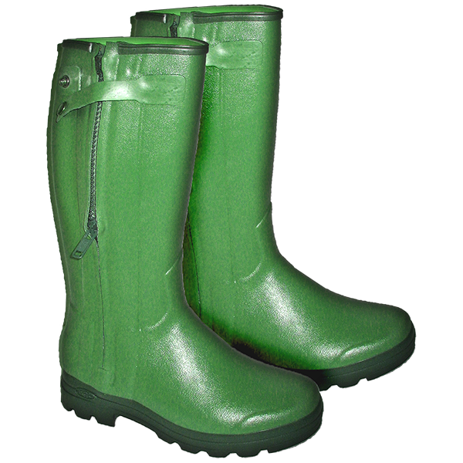
a face mask
eye protection
strong boots
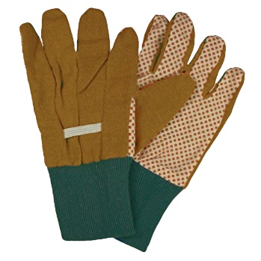
gloves
long trousers.

When you are cleaning up look out for dangers like:
burnt trees
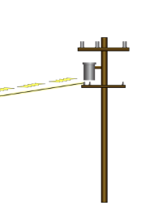
hot ashes on the ground
fallen electricity cables.

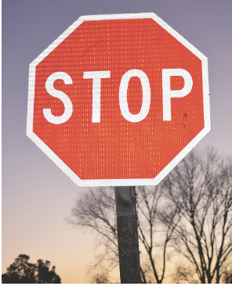
You should keep away from all trees until a tree expert has told you they are safe.

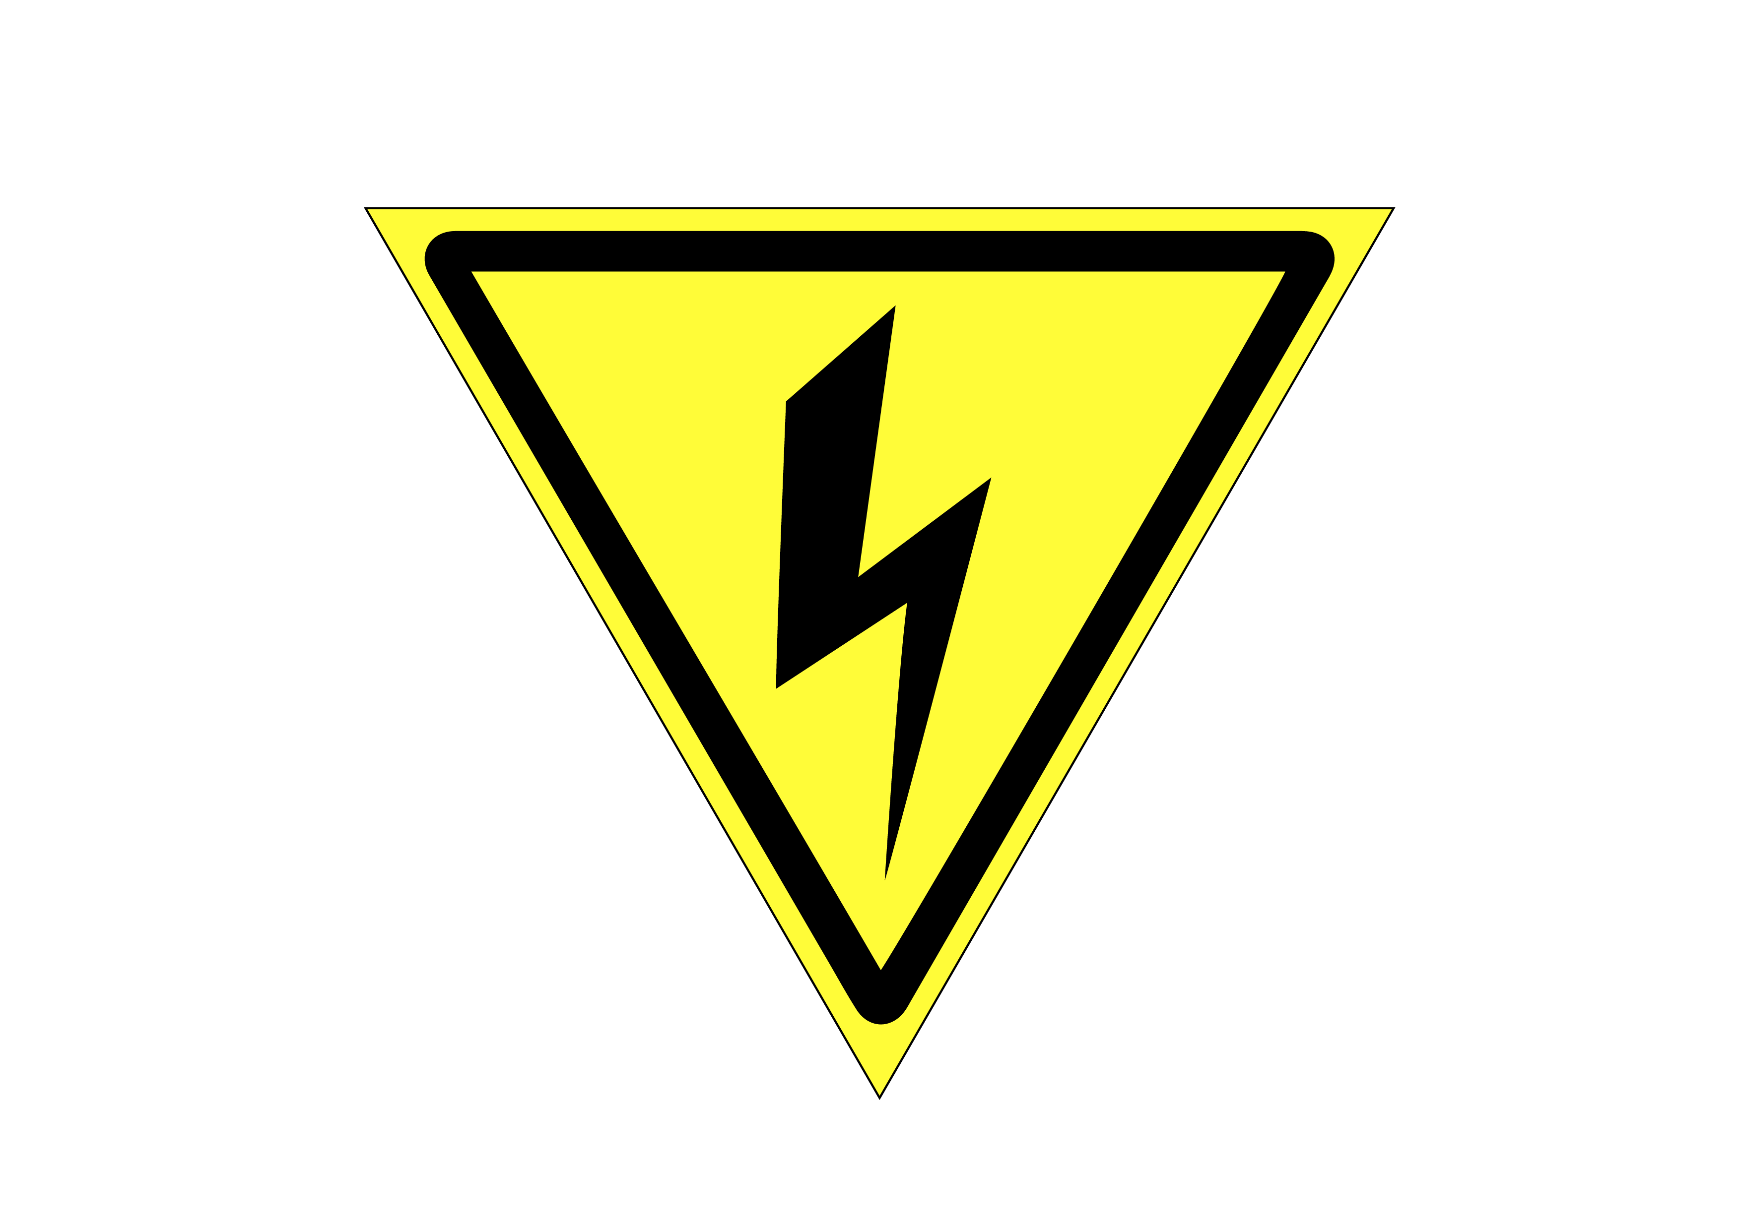
Electricity cables may be dangerous after a wildfire.

Do not touch electricity cables until you know they are safe.

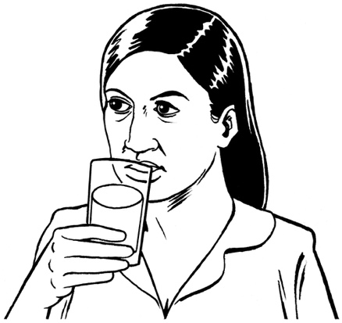
Always get advice from your local council before you / your animals:
drink water from storage tanks
eat food from your property.

Where to find more information

You can find more information about keeping yourself safe from wildfires on the Fire Emergency New Zealand website at:

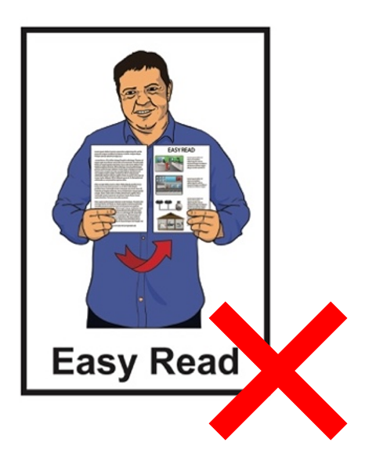
www.checkitsalright.nz

This website is not in Easy Read.

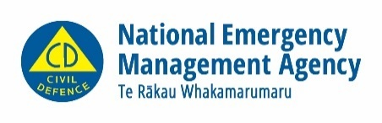
This information has been written by National Emergency Management Agency and Fire Emergency New Zealand

It has been translated into Easy Read by the Make it Easy Kia Māmā Mai service of People First New Zealand Ngā Tāngata Tuatahi.
The ideas in this document are not the ideas of People First New Zealand Ngā Tāngata Tuatahi.
Make it Easy uses images from:
- Changepeople.org

            - Photosymbols.com

- SGC Image Works
- Huriana Kopeke-Te Aho
- T. Wood.
All images used in this Easy Read document are subject to copyright rules and cannot be used without permission.

