If an earthquake is long or strong
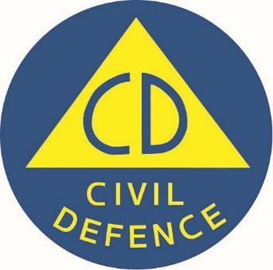
Logo: Civil Defence
www.civildefence.govt.nz

Produced 2022 by Accessible Formats Service, Blind Low Vision NZ,
Auckland
Total print pages: 2
Total large print pages: 2

Notes for the Large Print Reader
Print page numbers are indicated as:
Page 1
Main text is in Arial typeface, 18 point.

Page 1

If an earthquake is LONG or STRONG, GET GONE.
Move immediately to the nearest high ground
or as far inland as possible.
Don't wait for an official tsunami warning.
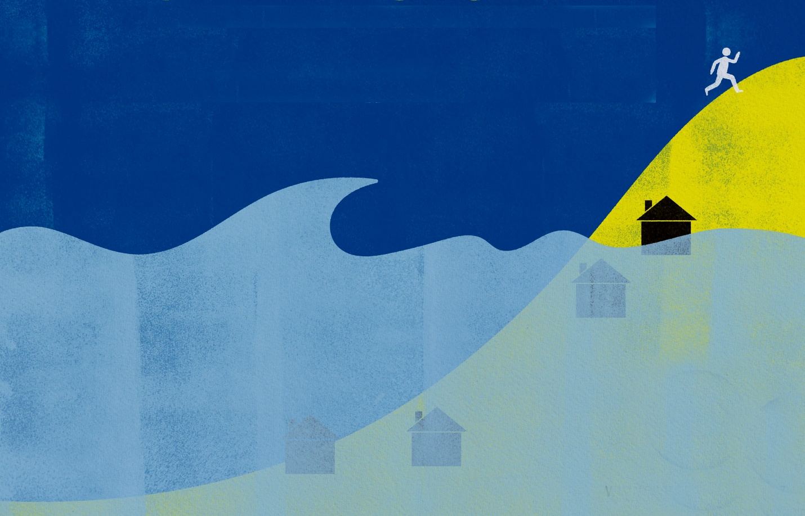
www.civildefence.govt.nz
Logo: Civil Defence
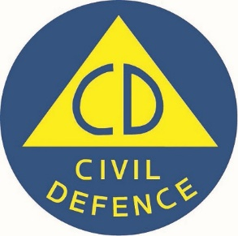
Page 2

If an earthquake is LONG or STRONG: GET GONE.
Move immediately to the nearest high ground or as far inland as possible. Don’t wait for an official tsunami warning.
All of our coastline is at risk of tsunami. Knowing the right immediate action to take can prevent injury and save lives.
If you are near the coast and feel an earthquake that is LONG or STRONG: GET GONE.
An earthquake that lasts more than a minute OR makes it hard to stand up is a natural tsunami warning.
If you are near the coast, don’t wait for an official warning. Move immediately to the nearest high ground or as far inland as you can. Walk or bike if you can. Stay there until you get the all clear.
Make a plan today. Find out who can help you and who might need your help. Your local Civil Defence Emergency Management Group has information for your region.
Logo: Civil Defence
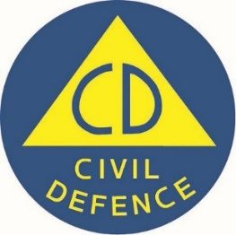

civildefence.govt.nz

