Get Ready –
Make a Plan

Produced 2022 by Accessible Formats Service, Blind Low Vision NZ,
Auckland
Total print pages: 4
Total large print pages: 11

Notes for the Large Print Reader
Print page numbers are indicated as:
Page 1
Main text is in Arial typeface, 18 point.
Headings are indicated as:

Heading 1

Heading 2

Heading 3

Page 1

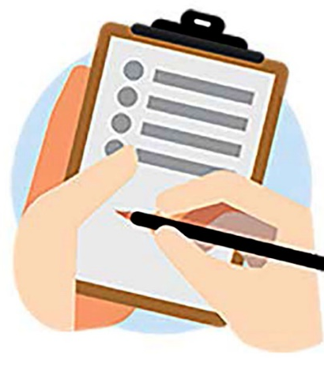
Get Ready – Make a Plan

Who is this plan for?

Household members
Name:

Contact Details:

Name:

Contact Details:

Name:

Contact Details:

Name:

Contact Details:

Does anyone have special requirements?
Will anyone in your household need assistance to evacuate, or while stuck at home during an emergency? Does anyone rely on mobility or medical devices or other special equipment? Does anyone rely on prescription medicine? Do they have supplies to last three days or more or alternatives if power is not available?

Any babies or young children?
Do you have nappies, formula, etc. to last three days or more if shops and roads are closed? Do you have supplies in a grab bag in case you need to leave in a hurry as well?

Any pets?
Your animals are your responsibility, so make sure you include them in your emergency planning. Do you have food and water to last three days or more? Do you have cages or carriers to transport them and keep them safe? Do you have someone to collect and look after your animals if you can't get home?

Anyone else who might need help?
Are there any friends, family or neighbours who might need your help to get through an emergency at home or to evacuate?
Name:

Contact Details:

Name:

Contact Details:

Name:

Contact Details:

Page 2

Useful contacts
Always dial 111 in an emergency. Think about your council's emergency hotline, medical centre/doctor, landlord, insurance company, power company, day care/school, work and family members.
Name: Emergency services
Contact Details: 111

Name:

Contact Details:

Name:

Contact Details:

If we can't get home

Our meeting place
Where will you meet if you can't contact each other and are separated when an emergency occurs? How will you get there?
Add an address and instructions.

Who will pick up the kids?
If you are not able to pick children up from school, day care, afterschool care, etc., who will? Do they know? Does the school / day care have their details?
Name:

Contact Details:

Name:

Contact Details:

Name:

Contact Details:

If we can't get hold of each other
Who will you check in with (someone out of town in case local phone lines are down)?
Name:

Contact Details:

Name:

Contact Details:

Name:

Contact Details:

We will get updates by
How will you find the latest news/alerts? Which radio stations will you listen to? Which websites and social media pages will you check?

Radio station/website/social media channel:

Radio station/website/social media channel:

Radio station/website/social media channel:

Page 3

If we are stuck at home

Do we have emergency supplies
Food and drink for three days or more (for everyone including babies and pets)? Torches, a radio, and batteries for both? First aid/medical supplies? They don't all need to be in one big box, but you may have to find them in the dark.
Make detailed notes on where these items are stored

Do we know how to turn off water, power and gas?
Only turn these off if you suspect a leak or damaged lines or if you are instructed to do so by authorities. If you turn the gas off, you will need a professional to turn it back on.
Details on how to turn off the water, power and gas

If we have no power
What will you need to do if there is no power? How will you cook, stay warm, see at night (do not use candles as they are a fire hazard)? Do you have spare cash in case ATMs are not working? Do you have enough fuel in case petrol pumps are not working?)
Make notes on what your household needs to do

If we have no water
What will you need to do if there is no water? Do you have enough drinking water stored (three litres per person per day for three days or more)? Do you have water for your pets? What will you cook and clean with? What will you use for a toilet?
Make notes on what your household needs to do

If we have to leave in a hurry

Do we have grab bags?
Does everyone have grab bags (* Footnote) in case you need to evacuate? At home, at work, in the car?
* Footnote: A small bag with warm clothes, a torch, radio, first aid kit, snack food and water.
Make detailed notes on where the grab bags are stored

Page 4

Where will we go?
Where you will go in case you have to evacuate? How will you get there? If you live near the coast, make sure it is outside of all tsunami evacuation zones. Where will you stay if you can't get back to your home?
Make detailed notes on where you will go and how you will get there

