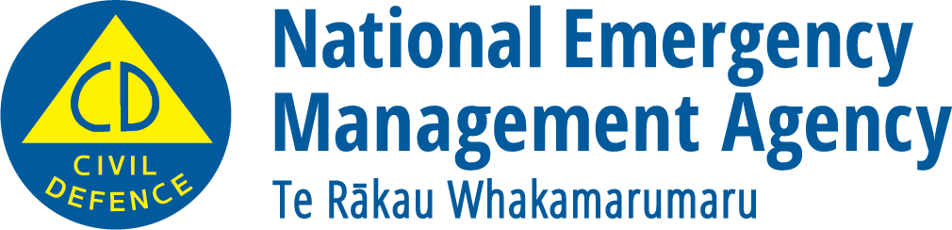

Wildfires
Adapted in 2024 by Accessible Formats Service, Blind Low Vision NZ, Auckland
TN: The logo on the top of the page is Civil Defence: National Emergency Management Agency | Te Rākau Whakamarumaru.

Wildfires
In New Zealand, people cause 98% of wildfires. They can happen any time of year, so your actions make all the difference.
You don't need to live in a rural area to be at risk from wildfire. If there's vegetation close by and potential for someone to generate a spark, then there's a wildfire risk.
Don't wait until there's smoke in the air to prepare. Help protect your property from wildfire.
Visit checkitsalright.nz to find practical steps you can take to reduce the risk of wildfire.
You can protect your property from wildfire by:
- Keeping your grass short and green, if possible, around buildings on your property.
- Keeping gutters and areas around decks clear of dead leaves, debris and pine needles.
- Removing highly flammable plants close to buildings on your property. This includes avoiding bark mulch or similar ground coverings, and
- Planting low flammability plants.
Learn how to protect your home at fireandemergency.nz/outdoor-and-rural-fire-safety/protect-your-home-from-outdoor-fires/
If you have a RAPID number, make sure it is visible at your property entrance. Your accessway must be wide enough for a fire engine (4m wide by 4m high).

Get ready before a wildfire.
Always check whether it's safe to light a fire and if you'll need a fire permit at checkitsalright.nz
Practice good fire safety when doing anything that could cause a spark.
Plan your escape route. When planning your route, you won't always know what direction the fire is coming from. It's important to have more than one way out.
Identify a safe zone that is clear of vegetation in case you can't evacuate and have to shelter in place. You may need to shelter in place on your property or in your community. A safe zone might be somewhere that has:
- large areas of concrete,
- well-maintained short grass, or
- large volumes of water.
Work out what supplies you might need and make a plan with your whānau. Make sure you include your animals in your plan.
Know how you will stay informed. Emergency services will always try to alert you to an approaching wildfire. But there may not be time to issue an official warning. Be aware of what is happening in your area.
Particularly if you see or smell smoke on a hot or windy day, because fire can move very quickly.

What to do during a wildfire.
If in doubt, get out!
Wildfires move quickly. If you can see smoke or flames from a wildfire and you feel unsafe, don't wait for an official warning to leave. Evacuate immediately. Call 111 if your life or property is threatened, or you can't evacuate on your own.
If you have time before you evacuate:
- turn on sprinklers,
- fill gutters with water, and
- wet down materials like firewood that may fuel the fire.

If there is time, you can also:
- move vehicles to a safe location;
- move lightweight outdoor items inside;
- wet down the sides of buildings, decks and plants close to your home;
- move animals and livestock to a well-grazed or ploughed area;
- close windows, doors and vents, and shut blinds; and
- seal gaps under doors and windows with wet towels.
Stay informed. Listen to the radio or follow your Civil Defence Emergency Management Group online.
Do not fly drones around the fire. Drones affect firefighting air operations.

What to do after a wildfire.
After a wildfire, only return home if you are told it is safe to do so. Watch out for firefighters still working in the area.
Some roads may still be closed because of:
- ongoing firefighting operations,
- fallen trees and branches,
- downed powerlines, or
- damage to roading infrastructure.
Stay informed because the situation can change quickly and get worse again. Listen to the radio or follow your Civil Defence Emergency Management Group online.
Watch out for burnt trees, hot embers on the ground and fallen powerlines.
Treat all damaged trees as dangerous. Don't walk under them until an arborist has assessed them.
Treat any fallen powerlines as live until the power authority has confirmed otherwise.
Get professional advice about ventilating and cleaning if your home or belongings smell of smoke. It's not uncommon after a wildfire for the smell of smoke or a smoky haze to remain for several days.
When cleaning up, wear:
- enclosed footwear,
- eye protection,
- gloves,
- a face mask,
- and long trousers.

Contact your local council's environmental health officer for advice before using:
- food collected from the property,
- onsite feed supplies for animals, or
- water from storage tanks for drinking.
Boiling water does not remove fire retardants or other chemicals from your water.
End of Wildfires

